Conclusion for exam exercises no. 2 factual questions on January 29, 2024

**Task 1.**

The first week we went through what accounting entails. All companies, i.e. sole proprietorships, joint-stock companies, trading companies, etc., must keep accounts. The accounting then leads each year to a financial statement.

Here are some questions.

*A, What is a business event?*

*Sale of an item. A salary payment, depreciation of a fixed asset, eg a vehicle. A purchase of a service.*

*B, How does bookkeeping work in practical terms. Briefly describe.*

*All business events are recorded in a business system. Chronological order, if we have a calendar year as a financial year, we start in January and end in December.*

*C, Even if bookkeeping is required by law, the company itself can benefit from the bookkeeping.*

*In which way?*

*Be able to go back and see what has happened. You can also follow up, for example, the income statement to see how the company is doing. We reach our goals.*

**Task 2.**

The accounting results in a financial statement, which then becomes an annual report.

The annual report is a public document that can be downloaded free of charge from various platforms such as hitta.se.

*A, Where does the company send its annual report?*

*It is sent to the Companies Registry. No later than 7 months after the end of the financial year.*

*B, How long must each company keep its financial statements?*

To be saved for 7 years

**Task 3.**

*A, Why is the company's share capital on the liability side of the balance sheet?*

*Because it is the company's fault. The legal person company that has a debt to the shareholders who deposited money in the company.*

*B, What is balance sheet for something?*

Total assets = total assets.

Total Ek and liabilities = balance sheet total.

They should be the same size on both sides.

**Task 4.**

A company has SEK 450,000 in fixed costs in 2023.

In 2023, goods for SEK 3,450,000 have been sold. These cost SEK 2,500,000 in purchases, i.e. KSV, cost of goods sold was SEK 2,500,000.

*A, What is the gross profit?*

SEK 950,000.

*B, What should the gross profit cover?*

The company's fixed costs.

*C, What was the profit?*

SEK 500,000

*D, What was the profit margin?*

About 14 percent

**Task 5.**

We have worked with break-even on the course, or zero point as it says in the book.

A company has fixed costs of SEK 950,000.

They sell a type of children's bicycle. The bicycle costs SEK 550 to purchase and is sold to the customer for SEK 1,200.

A, How many bikes must the company at least sell to break even, i.e. what is break-even?

1462 bicycles. 950,000 / 650 TB then becomes, as said, 1462 bikes.

B, How many bicycles must the same company at least sell to also get a profit of SEK 130,000? 950,000 + 130,000 = 1,080,000 / 650 TB is then 1,662 bikes.

**Task 6.**

*Not all companies have to have an accountant, but of course you can still choose one. But at what limits must a limited liability company have an auditor?*

*Three different criteria, two of which must be met. Then you must have an accountant. The three criteria are:*

*Employees more than 3, assets with a value of more than SEK 1.5 million and a turnover of more than SEK 3 million.*

**Task 7.**

*How would you like to define a key figure?*

*A number that you show interest in, i.e. not just any number. A speech can be interesting for the company for a certain time and then not be interesting at all.*

**Task 8.**

*It can be said that key figures are good to use in mainly three different situations.*

*Who are these?*

*When you want to achieve a goal within a certain time, e.g.*

*Comparisons over time. External compared to other companies. Internally over the years, turnover per employee has increased in the last 4 years. Becomes a trend scout.*

**Task 9.**

What is meant by financial benefit in the future when discussing investments?

*Investment should give something back. Economic benefit can be both increased revenue and/or reduced costs.*

**Task 10.**

*Why can post-calculation be so valuable to do?*

*To check how the pre-calculation was correct. Learn from this and benefit from future calculations.*

**Task 11.**

*In what way can you say that calculus is a simplification of reality?*

*Instead of going in every day and checking the currency, you can use a standard assessment one month at a time.*

*Costs of lesser value that are difficult to calculate or of minor importance are not included.*

**Task 12.**

A company that only sells toasters had an inventory value of SEK 40,000 at the beginning of the year. At the inventory in May, they had an inventory value of SEK 60,000, in September SEK 45,000 and at the end of the year SEK 55,000.

*A, What was the average inventory for the year?*

*40000 + 60000 + 45000 + 55000 = 200000*

*200,000 divided by 4 measurement occasions = SEK 50,000 in average stock.*

**Task 13.**

A company has a relationship with a variety of stakeholders of which relationships with customers is one.

Name at least 4 other stakeholders that a company has a relationship with.

* Agencies.
* Employees.
* Suppliers.
* Municipalities.
* The bank and others

**Task 14.**

Many companies prefer to lease instead of borrowing and acquiring, for example, an expensive machine.

Describe below short leasing goes to?

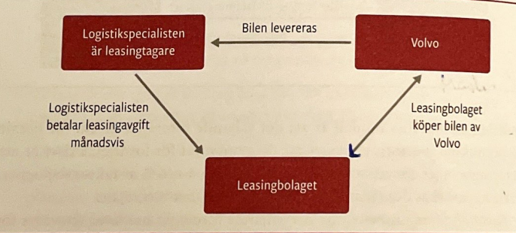

**Task 15.**

Factoring can be done in at least two different ways, which we discussed in the course.

One is that the finance company buys parts of the company's invoices. The second is the most common, ie the company mortgages its invoices with a finance company.

Describe below how invoice financing works with a finance company?

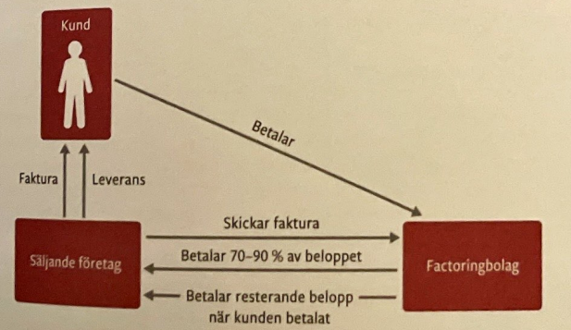

**Task 16.**

It is not unusual for a company to temporarily run out of money, i.e. a lack of liquid funds.

What can the company do in the short term in such a situation?

* Borrow from shareholders.
* Open a checking account.
* Have a dialogue with a known customer about paying the invoice before the due date in return for interest compensation or a cash discount.
* Have a dialogue with a known supplier about being able to pay something later, possibly with a late payment interest.